I
n this session we will go through user task.

A User Task is used to model work that needs to be done by a human actor. When the process execution arrives at such a User Task, a new task is created in the task list of the user(s) or group(s) assigned to that task.

User task

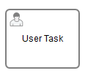

User Task Properties:
General:
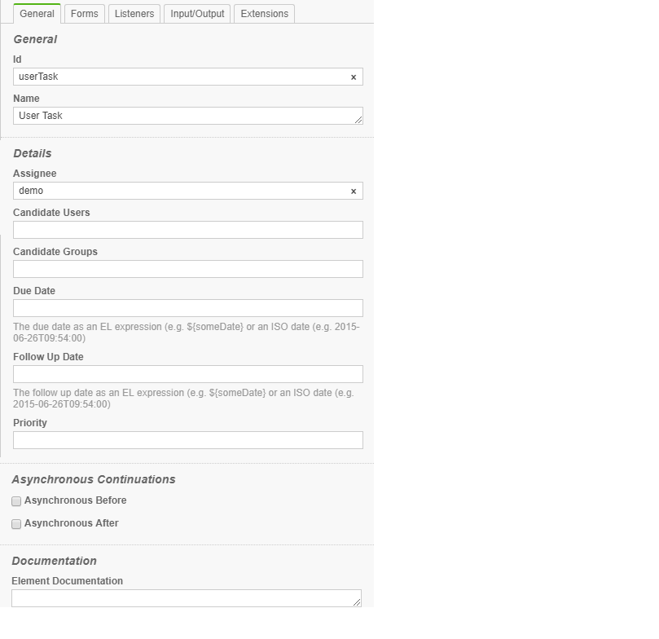
Id: Id of task

Name: Name of task

Assignee: This custom extension allows direct assignment of a User Task to a given user.

Candidate Users: This custom extension allows you to make a user a candidate for a task.
Candidate Groups: This custom extension allows you to make a group a candidate for a task.

Due Date: Each task has a field indicating the due date of that task. The Query API can be used to query for tasks that are due on, before or after a certain date.
The due date of a task can also be altered using the TaskService or in TaskListeners using the passed DelegateTask.

Follow Up Date: Each task has a field indicating the follow up date of that task. The Query API can be used to query for tasks that need to be followed up on, before or after a certain date.

Priority: The attribute specifies the initial priority of a User Task when it is created.

Default value is valid java long value : 50

Asynchronous Before: Specifies an asynchronous continuation after an activity

Asynchronous After: Specifies an asynchronous continuation before an activity

Element Documentation: A User Task can also have a description. In fact, any BPMN 2.0 element can have a description. A description is defined by adding the documentation element.

Exercise User Task with Assignee:

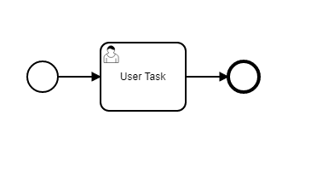
User Task Properties:

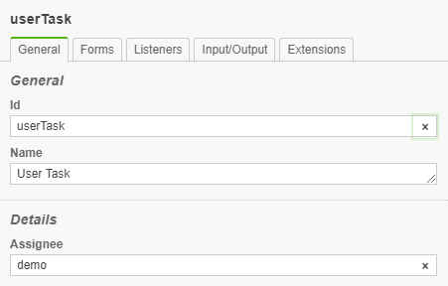

This user task is assigned to demo user.

Task Form:

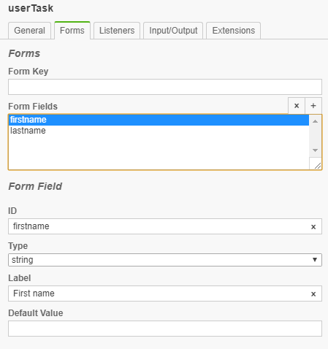
When user task is created. Default form with field firstname and lastname will be presented to user demo.

Deploy and Test the process

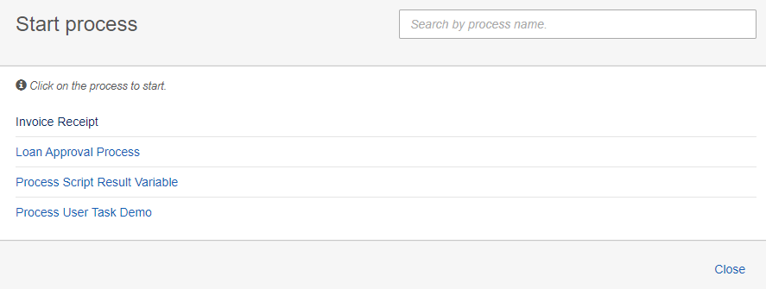

Start Process:
Start Process User Task Demo.
User task:
User task will be created and assigned to demo user as below

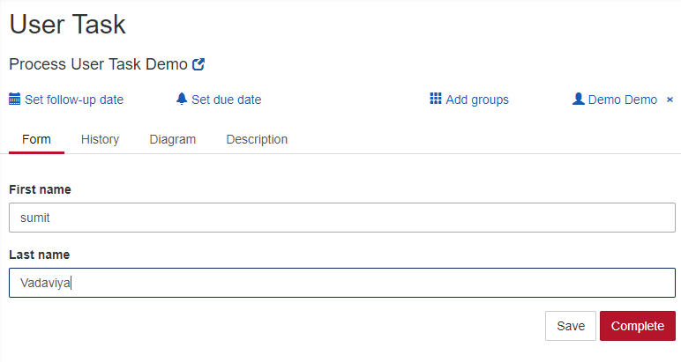
Click the Complete button.
Process will be completed.

Exercise User Task with Candidate User:
User Task Properties:

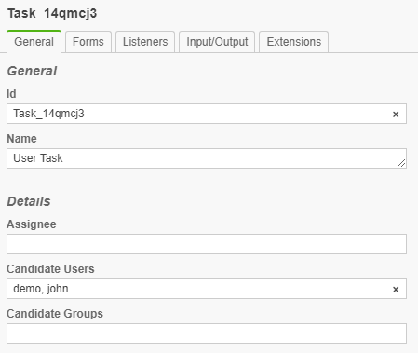

Demo and john user will be candidate for this user task to work on.

Deploy the process

Login as demo user to Camunda TaskList application.

Create Filter:
Create filter to list user task which demo user can work on.

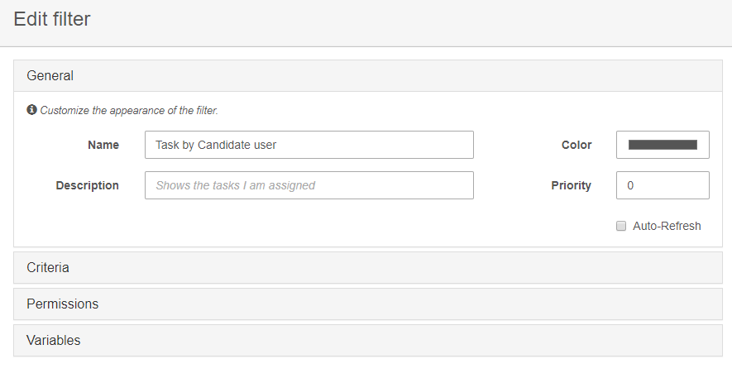

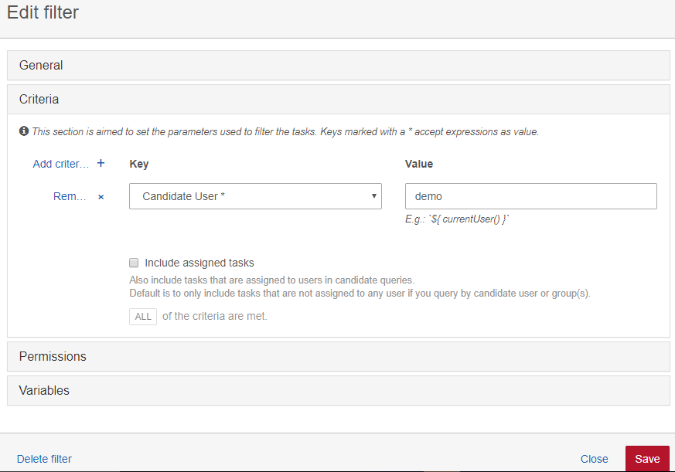

Save the filter configuration.

Start the Process

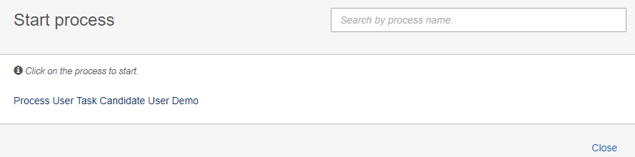

Claim and complete user task:

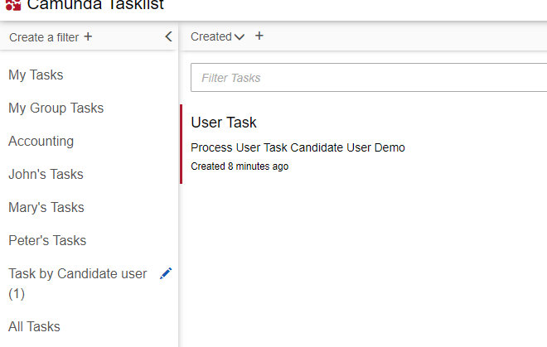

You can see filter Task by Candidate user has on task which demo user can claim and complete.

User Task with Candidate Groups:

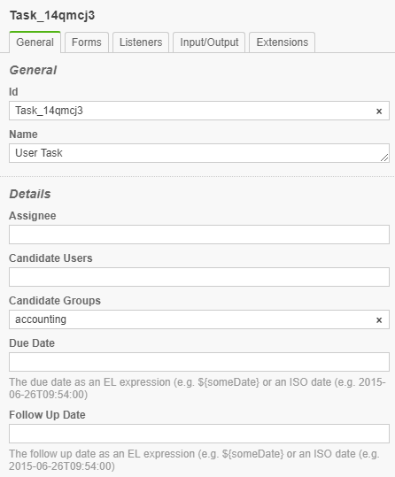

Deploy the process

Start the process
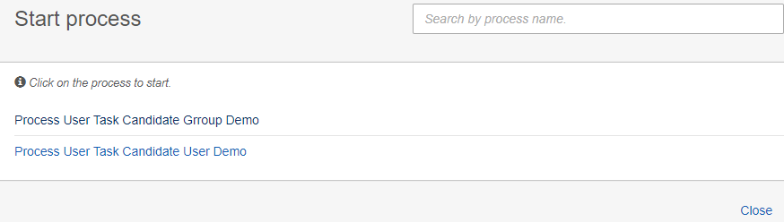

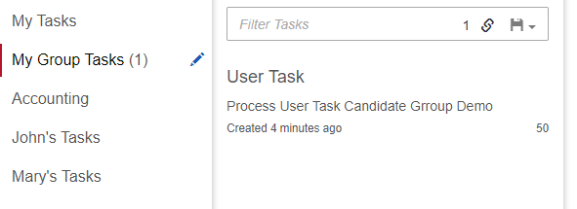

Task Detail
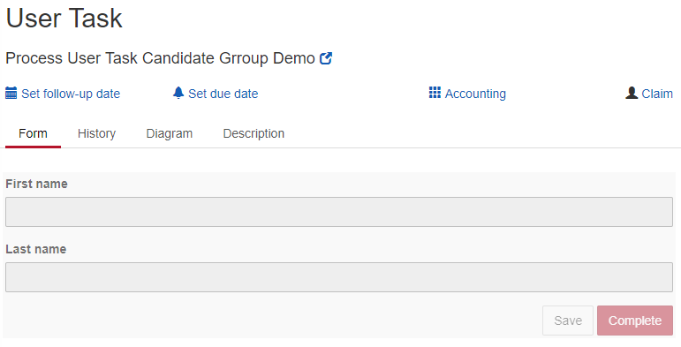
User task is assigned to accounting group.

User can claim and complete the task

User Task Due Date:
Set Due Date to 2019-12-22T12:00:00

User Task Follow Up Date:
Set Follow Up Date to 2019-11-22T11:00:00

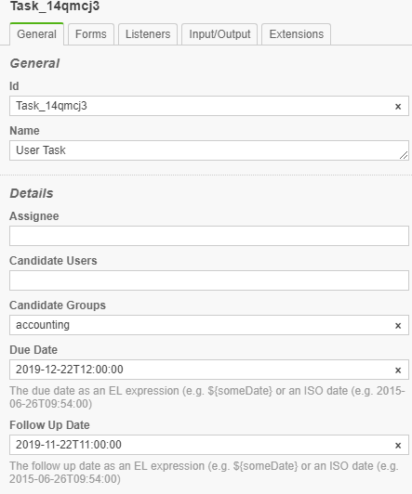

Deploy the process and Start process

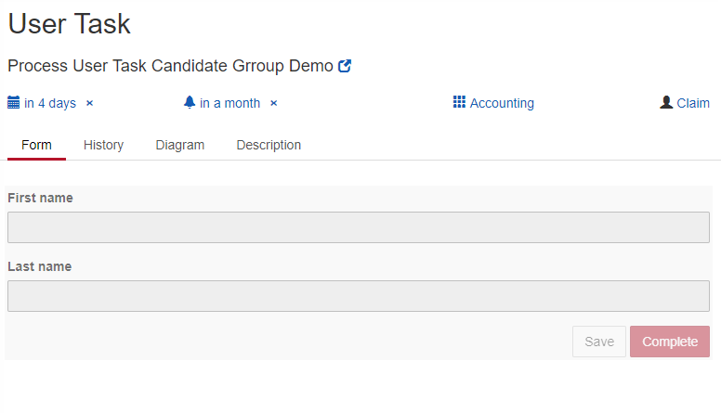

Deploy User Task Form Field Validation

Validation can be used for specifying frontend and backend validation of form fields. Camunda BPM provides a set of built-in form field validators and an extension point for plugging in custom validators.

The following built-in validators are supported out of the box:

Validator | Explanation
required | Applicable to all types. Validates that a value is provided for the form field. Rejects 'null' values and empty strings.  eg. <camunda:constraint name="required" />
minlength | Applicable to string fields. Validates minlength of text content. Accepts 'null' values.  eg. <camunda:constraint name="minlength" config="4" />
maxlength | Applicable to string fields. Validates maxlength of text content. Accepts 'null' values.  eg. <camunda:constraint name="maxlength" config="25" />
min | Applicable to numeric fields. Validates the min value of a number. Accepts 'null' values.  eg. <camunda:constraint name="min" config="1000" />
max | Applicable to numeric fields. Validates the max value of a number. Accepts 'null' values.  eg. <camunda:constraint name="max" config="10000" />
readonly | Applicable to all type. Makes sure no input is submitted for given form field.  eg. <camunda:constraint name="readonly" />

Camunda 8.1

User tasks
A user task is used to model work that needs to be done by a human actor. When the process instance arrives at such a user task, a new job similar to a service task is created. The process instance stops at this point and waits until the job is completed.

Applications like Tasklist can be used by humans to complete these tasks.
Alternatively, a job worker can subscribe to the job type io.camunda.zeebe:userTask to complete the job manually.
When the job is completed, the user task is completed and the process instance continues.

User task forms​
User tasks support specifying a formKey attribute, using the zeebe:formDefinition extension element. The form key can be used to specify an identifier to associate a form to the user task. Tasklist supports embedded Camunda Forms, these can be embedded into the BPMN process XML as a zeebe:UserTaskForm extension element of the process element.

Assignments​
User tasks support specifying assignments, using the zeebe:AssignmentDefinition extension element. This can be used to define which user the task can be assigned to. One or both of the following attributes can be specified simultaneously:
- assignee: Specifies the user assigned to the task. Tasklist will claim the task for this user.
- candidateGroups: Specifies the groups of users that the task can be assigned to.
Typically, the assignee and candidate groups are defined as static values (e.g. some_username and sales, operations), but they can also be defined as expressions (e.g. = book.author and = remove(reviewers, book.author)). The expressions are evaluated on activating the user task and must result in a string for the assignee and a list of strings for the candidate groups.
For Tasklist to claim the task for a known Tasklist user, the value of the assignee must be the user's unique identifier. The unique identifier depends on the authentication method used to login to Tasklist:
- Camunda Platform 8 (login with email, Google, GitHub): email
- Default Basic Auth (elasticsearch): username
- IAM: username
NOTE
For example, say you log into Tasklist using Camunda Platform 8 login with email using your email address foo@bar.com. Every time a user task activates with assignee set to value foo@bar.com, Tasklist automatically assigns it to you. You'll be able to find your new task under the task dropdown option Claimed by me.

Variable mappings​
By default, all job variables are merged into the process instance. This behavior can be customized by defining an output mapping at the user task.
Input mappings can be used to transform the variables into a format accepted by the job worker.

Task headers​
A user task can define an arbitrary number of taskHeaders; they are static metadata handed to workers along with the job. The headers can be used as configuration parameters for the worker.

Additional resources​

XML representation​
A user task with a user task form and an assignment definition:
<bpmn:process id="controlProcess" name="Control Process" isExecutable="true">
<bpmn:extensionElements>
<zeebe:userTaskForm id="userTaskForm_2g7iho6">
<!-- Task Form Content -->
</zeebe:userTaskForm>
</bpmn:extensionElements>
<bpmn:userTask id="Activity_025dulo" name="Configure">
<bpmn:extensionElements>
<zeebe:assignmentDefinition assignee="= default_controller" candidateGroups="controllers, auditors" />
<zeebe:formDefinition formKey="camunda-forms:bpmn:userTaskForm_2g7iho6" />
</bpmn:extensionElements>
</bpmn:userTask>
</bpmn:process>

